BI SECURITY – SECURITY RECOMMENDATION REPORT

Objective: To design a secure access strategy for Global Superstore reports using authentication, authorization, role-based permissions and Row-Level Security (RLS).
User Roles and Access Requirements: The CEO needs overall business performance information. The Sales Manager needs sales and customer information. The Finance Manager needs revenue and profit information, while Regional Managers need data related to their assigned regions.
Authentication Analysis: Username-password authentication provides basic identity verification. Organizational accounts support centralized user management. Multi-Factor Authentication (MFA) adds another verification step and provides stronger protection against unauthorized account access.
Authorization and Access Control: Permissions were planned according to job responsibilities. General managers receive only the access needed for their work, while the BI Administrator receives permissions required to manage reports and security. This follows the principle of least privilege.
Row-Level Security Implementation: Two RLS roles were created in Power BI using the Dim_Region table. North_Manager uses the filter [Region] = "North Africa", while South_Manager uses [Region] = "Southern Asia". Both values are present in the dataset.
North_Manager test result: Using View as, the Sales by Region visual displayed North Africa only. The dashboard showed total sales of approximately 233.16K and total profit of 57.83K.
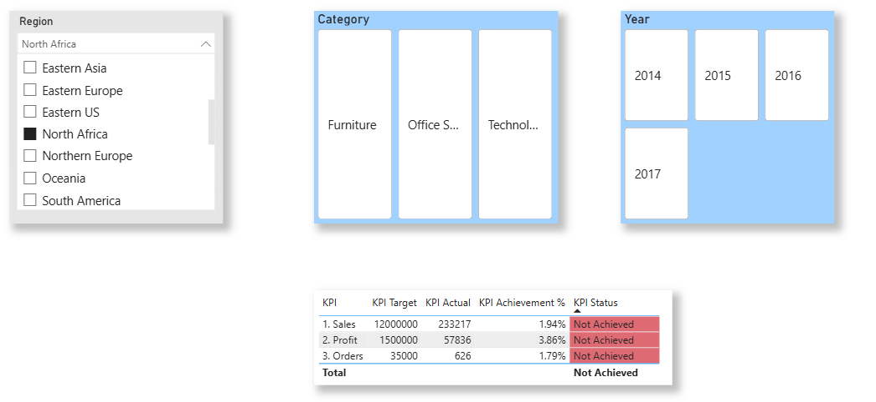
Figure 1: RLS test for North_Manager – North Africa data only.
South_Manager test result: Using View as, the Sales by Region visual displayed Southern Asia only. The dashboard showed total sales of approximately 866.57K and total profit of 159.34K.
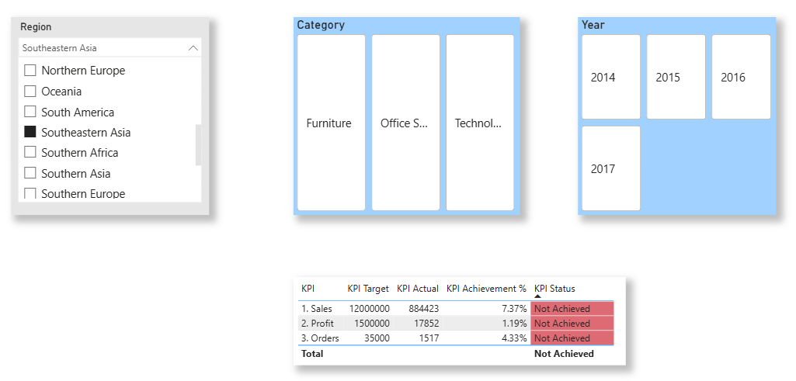
Figure 2: RLS test for South_Manager – Southern Asia data only.
Security Risk Assessment:
Risk | Description | Impact | Likelihood | Mitigation
Data Leakage | Data exported to Excel or CSV, shared links forwarded, or screenshots shared | High | High | Sensitivity labels, restrict export, limit sharing, train users
Excessive Permissions | Users hold more access than they need | High |  | Least privilege, assign roles by job, review quarterly
Missing RLS | Regional managers see other regions’ data | Medium | Medium | Implement and test RLS roles before publishing
Outdated Accounts | Leavers or role-changers keep access | Medium | Medium | Remove access on leaving, regular audits
Unauthorized access | Someone without permission views the reports | High | Medium | Entra ID login, MFA, workspace roles, regular access reviews

Security Recommendations:
Recommendations | Priority | Owner
Apply least-privilege roles and review them quarterly | High | BI Administrator
Audit access logs and remove inactive accounts | Medium | IT Security
Enforce MFA for all users, especially executives and admins | High | IT Security
Implement RLS for all regional users and test it with “View as” | High | BI Developer
Limit sharing to named users or groups, not “anyone with the link” | Medium | BI Administrator
Train users on data-handling and phishing awareness | Low | HR / IT
Use sensitivity labels and restrict export for confidential reports | Medium | Data Governance

Conclusion: A BI security strategy was designed using authentication, authorization and access control principles. Role-based permissions and two Row-Level Security roles were configured and tested successfully in Power BI Desktop. Common security risks were identified and suitable controls were recommended.

